Guiding Questions | Framework Connection
What do you want the students to know and be able to do?
- Explain the BIG ideas and knowledge students must obtain in your specific content area? What is the scope and sequence of learning for this class?

If I am successful in my teachings, students should be able to develop their analytical and critical thinking skills through close reading, discussion/presentation of information, and writing. Throughout the year students learn about the major themes literature has to offer and analyze how authors use figurative language to enhance their stories. In order for students to express their idea and share their knowledge, they will create argumentative, narrative, and informative essays using the up to date Modern Language Association formatting (MLA).

- How will you communicate the learning objectives to the students?  I will communicate my learning objectives to the class verbally at the beginning of the period and also write them on the board so that students can refer back to them during the day. | 3a
- Describe your thinking and process for selecting instructional materials and resources outside of the core curriculum.  When creating units for my classes I typically try to backtrack from where I would like the students to be at the end of the unit. If I am teaching the students about Figurative Language and I want them to master 12 different words by the end of the unit, I would find a text that has examples of each word so that I can scaffold my lessons using both the text and the definitions.  Since instructional material and resources like text books cost the school money, I do my research in order to make sure the resources will be compatible for years as opposed to just one semester. If I am unable to use my instructional material to scaffold my lessons with other units of my own or classes like history than I would not use them in my classroom. | 1d, 1e
- Are there any students you would especially like me to observe?  There are a number of students who have scored lower on their state testing in the past. While I will be checking in with these students more often, there aren’t any students that I would be worried about. | 1b, 1e
How will you know that the students have learned? How will you respond to their learning?
- How and when will you know whether students have learned what you intend?  In order to get the most reliable information on how much students have learned, it is important that I give formative assessments each week in order to maintain an accurate record. The 6th Grade students are given homework assignments each week which ask students to recall content and skills from the previous weeks and units in the past. These homework assignments can be used as formative assessments but I also try to give the students different types of formative assessments such as quizzes, jigsaw activities, and group projects.  For the lesson that will be observed during my evaluation, the students will be having a summative assessment on the different types of Figurative Language we went over throughout the Frightful’s Mountain unit.  No matter which unit I am teaching, I always follow the same assessment style for the students:  - Throughout my lessons I have group activities where the students answer questions about the unit topics together.  - I give homework each week which helps emphasize what had been learned the previous week.  - I give formative evaluations through bell ringers and quizzes.  - I give a summative assessment at the end of the unit. | 1f, 3d
- What difficulties do students typically experience in this area?  I have found that the students in the 6th grade class are divided between visual learners, kinesthetic learners, and auditory learners. After giving multiple different types of tests last semester including a written test, a verbal test, and a test where students created their own 3d diagram, I noticed that students performed better in different ways. Most students are able to perform at a basic level with written exams, but almost every student produced exceptional work when they were given a test that allowed them to use their creativity. If students enjoy the activity they are working on, they are typically able to perform better on their assessments.  With this information in mind, I have been trying to diversify the way I assess student knowledge this semester. | 1a
- What adjustments do you typically make when students are struggling with concepts?  When I notice a student struggling with a concept I try to help them one-on-one in the classroom and schedule a time to meet during the morning advisory if they are still struggling. I make Kahoots and Quizlets for the 6th grade students who need to process the information in a different manner using the computers. If students do not have access to a device at home, I will help them make flashcards or give them alternative homework assignments to help with the area of difficulty. | 3d, 3e
- How do you differentiate for students who do not “get it?”  If students are struggling with a concept in class I will try to work with them one-on-one or meet with them during advisory or after school. Once I meet with the student and determine the specific area they are struggling with, I will give them alternative homework assignments so that they can learn at their own pace. When a student has worked with me on a concept they are struggling with, I will give them a formative assessment in the form of a small quiz or assignment in order to make sure they have learned the material. | 3e
Instructional Strategies and Feedback to Students
- Describe the strategies you use to engage students in the learning process?  In order to connect with the students and get them excited about what they are learning I do my best to show the same excitement I would like them to have. Although there are times when the assignments simply are not going to be fun or entertaining, I don’t lie to them and say that it will be. I am honest with them about the material being necessary for their education and they tend to enjoy my honesty. Whenever I can, I try to make assignments enjoyable for the students so that they will give their best effort on the assignment.  For instance, Figurative Language is not the most fun topic to learn about but when I make an assignment that involves groups and dioramas, the kids get excited to show what they have learned. | 3b, 3c
- How do you address off-task classroom behavior by students during instruction?  These are the following procedures I use in my classroom to address off-task behavior. It works like a strike system.  - I stand next to the student and tap their desk in order to let them know they are not behaving according to my classroom standards.  - I remove any distractions from their desk and have the students put them in their backpacks (toys, books, erasers). Any student that gets a toy taken away will have their next teacher be notified.  - I have the student move to the seat right next to my desk. Any student who gets seated next to me will have their parents emailed about their off-task behavior.  - If the student is still unable to stay on-task after the previous three steps, they will leave the room to either Mrs. White’s or Mrs. Bowen’s classrooms in order to reset and refocus themselves.  While I have the procedures in place to handle off-task or disruptive behavior I find that I rarely have to use them due to the point system I have made for my classroom. The students are divided between six different table groups which earn points each day in order to receive a homework pass for one night of the English Homework assignments. Students who misbehave in class lose points for their group and risk losing break time for their table. So far this system has been used for 2 months and the students have responded very positively to the process. | 3b
- Explain your process and reasoning for grouping students?  I group my students based on their behavior and their academic ability. By seating students next to others who are challenged by the material it allows them to work together and help each other improve. Students can gain enrichment by “teaching” students about material they have previously mastered since teaching others is the best way to show mastery. Students who are struggling with concepts can either ask me for help or they can ask their table partners.  I try to help students solve problems on their own using their resources and I consider their table partners a valuable recourse in the classroom. This method of grouping students only works due to the training I had with the students at the beginning of the year. I taught students how it is better to help others solve problems by teaching them as opposed to just giving them the answer. | 3c
- What data do you keep as evidence of differentiation and/or intervention for different individuals or groups of students in the class?  In order to show differentiation and intervention for students I use a website called  Newsella and Vocab.com for enrichment and intervention with the standards of  close reading and vocabulary. For students that are struggling with an individual  concept, I create a differentiated homework assignment for the concept in order to  give more practice.  Students that are well above the other students in class typically will need  enrichment activities which I provide through small essay questions using Newsella.  These enrichment activities involve reading a recent article in the news that has been  rewritten to the child’s reading level (which Newsella provides through the student  profile) and writing an opinion essay about their thoughts on the article. | 1e
- How do you provide feedback to students regarding their learning during instruction?  I give verbal feedback to students each day on their warm up, individual work, and  group projects. When students turn in their work, they receive feedback by the end  of the week on how they did on the assignment and what they could do to earn a higher score.  I recently started to try a new form of feedback through the use of my “Table of  Fours”. I started this idea at the beginning of the year when students in my 6th Grade  class were confused about how to earn a “4” on their assessments. Since they were  still confused after going over the rubric, I decided to use projects created by the  students to give a visual representation of how to earn the highest score possible.  The “Table of Fours” is simply the place in my room where I am able to display  work that has achieved the highest score possible. | 3d
- How will you provide feedback to students regarding their progress toward student learning objectives?

I give both verbal feedback each day to table groups regarding the activities we are working on that relate to the learning standards for English. Each time students turn in an assignment I do my best to get a grade back to the students by the end of the week with written feedback on Schoology or PowerSchool. It is important to me that I give good feedback to students before any quizzes or tests so they have every opportunity to learn from their mistakes and capitalize on their success for the upcoming assessments.

O’Leary 3/10/2020 Lesson Plan

3/10  Tues. | Learning Objective:  Students will look at various examples of imagery in order to get ready for their formative quiz the next day.  SWBAT analyze the imagery used in various writing samples in order to determine the type of senses the author wanted to appeal to.  EQ: How can figurative language be used to enhance writing? | Bell Ringer:  Students will work on the grammar activity called a MUG when they walk into the room. | Activity:  Imagery Worksheet:  Students will fill out the front side of the imagery worksheet which will challenge students to decide which type of senses are being appealed to in each writing sample.  (10 Min)  (RS- 2)  Imagery Activity:  Students will use their worksheet to analyze each of the 8th Grade Imagery Project in order to get a physical representation of how imagery can be used in various texts. After the students analyze each project, they will choose which project they feel accomplished the goal of physically showing the imagery the best and write a complete paragraph with reasons to back up their choice.  Classroom Discussion:  How can imagery be used in the informative essays that students are working on?  (5 Min)  (RS-2) | Homework:  The students will be responsible for completing the Tuesday section of the homework worksheet.  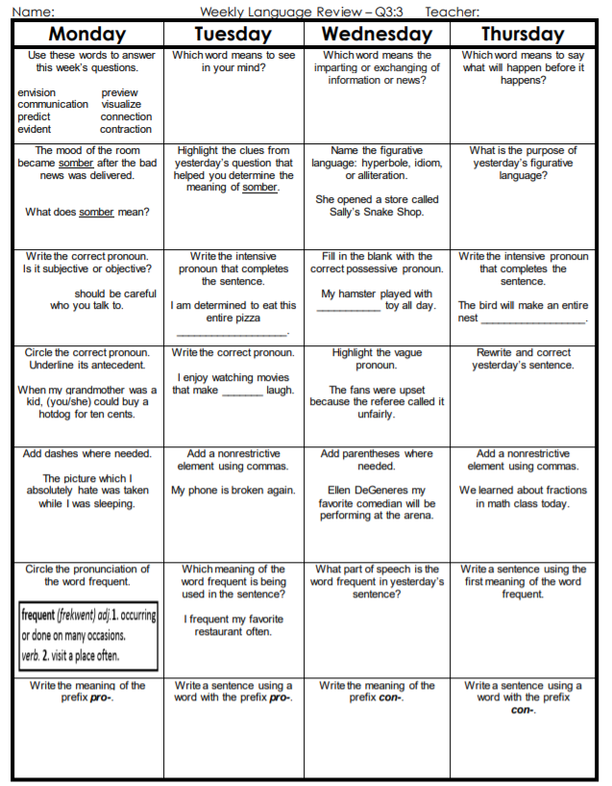

Imagery Activity Sheet for 3/10
Name____________________________________ Class ___________
Imagery

Quote | Circle the sense that appealed to you. | How?
The familiar tang of his grandmother’s cranberry sauce reminded him of his youth.
The concert was so loud that her ears rang for days afterward.
The sunset was the most gorgeous they’d ever seen; the clouds were edged with pink and gold.
After eating the curry, his breath reeked of garlic.
The tree bark was rough against her skin.

Look at each of the 8th Grade TKAM Shadowboxes displayed at each table and choose your favorite project. Write a paragraph explaining what caused you to think the project best depicted the imagery from the quote they have displayed on their box. Which senses did the 8th Grade group appeal to? Which words from their chosen quotation seemed to help the students create a visual representation? What would you have done differently?

_________________________________________________________________________________
_________________________________________________________________________________
_________________________________________________________________________________
_________________________________________________________________________________ _________________________________________________________________________________
_________________________________________________________________________________ _________________________________________________________________________________
_________________________________________________________________________________ _________________________________________________________________________________
_________________________________________________________________________________ _________________________________________________________________________________
_________________________________________________________________________________ _________________________________________________________________________________
_________________________________________________________________________________

3/9-3/13 6th Grade Homework

